Experiment No. 4
Aim: Implement stack operations using an interface
1. Stack Operations using Interface: Create an interface Stack with a variable size and abstract methods push(), pop(), display(), overflow(), and underflow(). Implement a subclass IntegerStack that implements the Stack interface. Create a test class to check the working of all methods in the IntegerStack class.

interface Stack {
int size = 5;
void push(int data);
int pop();
void display();
boolean overflow();
boolean underflow();
}

class IntegerStack implements Stack {
private int[] arr = new int[size];
private int top = -1;

public void push(int data) {
if (overflow()) {
System.out.println("Stack Overflow");
return;
}
arr[++top] = data;
System.out.println(data + " pushed");
}

public int pop() {
if (underflow()) {
System.out.println("Stack Underflow");
return -1;
}
int val = arr[top--];
System.out.println(val + " popped");
return val;
}

public void display() {
if (underflow()) {
System.out.println("Stack is empty");
return;
}
System.out.print("Stack elements: ");
for (int i = top; i >= 0; i--) {
System.out.print(arr[i] + " ");
}
System.out.println();
}

public boolean overflow() {
return top == size - 1;
}

public boolean underflow() {
return top == -1;
}
}

public class StackTest {
public static void main(String[] args) {
IntegerStack s = new IntegerStack();

s.push(10);
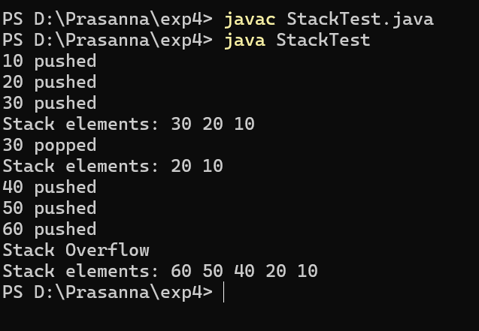
s.push(20);
s.push(30);
s.display();

s.pop();
s.display();

s.push(40);
s.push(50);
s.push(60);
s.push(70);
s.display();
}
}

2. Shape Interface with Rectangle and Triangle: Implement the following: a. Create an interface Shape with an abstract method area(). b. Create two classes, Rectangle and Triangle, that implement the Shape interface. c. Calculate and display the area of both Rectangle and Triangle.

interface Shape {
double area();
}

class Rectangle implements Shape {
private double length;
private double width;

public Rectangle(double length, double width) {
this.length = length;
this.width = width;
}

public double area() {
return length * width;
}
}

class Triangle implements Shape {
private double base;
private double height;

public Triangle(double base, double height) {
this.base = base;
this.height = height;
}

public double area() {
return 0.5 * base * height;
}
}

public class ShapeTest {
public static void main(String[] args) {
Shape r = new Rectangle(10, 5);
Shape t = new Triangle(10, 5);

System.out.println("Rectangle Area: " + r.area());
System.out.println("Triangle Area: " + t.area());
}
}
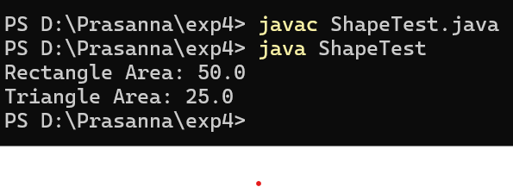

3. Student Exam Results Using Inheritance and Interface in: Implement the following
hierarchy:
a. Create a class Student with a variable rollNo and methods getRollNo() and
setRollNo().
b. Create a class Test that inherits Student and has variables sub1 and sub2 with
methods getMarks() and setMarks().
c. Create an interface Sports with a variable sMarks and a method set().
d. Create a class Result that inherits Test and implements the Sports interface. It should
display the marks.
e. Demonstrate the functionality of these classes in a test application.

class Student {
protected int rollNo;

public void setRollNo(int rollNo) {
this.rollNo = rollNo;
}

public int getRollNo() {
return rollNo;
}
}

class Test extends Student {
protected int sub1, sub2;

public void setMarks(int sub1, int sub2) {
this.sub1 = sub1;
this.sub2 = sub2;
}

public void getMarks() {
System.out.println("Subject 1: " + sub1);
System.out.println("Subject 2: " + sub2);
}
}

interface Sports {
int sMarks = 0;
void set(int sMarks);
}

class Result extends Test implements Sports {
private int sportsMarks;

public void set(int sMarks) {
this.sportsMarks = sMarks;
}

public void display() {
int total = sub1 + sub2 + sportsMarks;

System.out.println("Roll No: " + getRollNo());
getMarks();
System.out.println("Sports Marks: " + sportsMarks);
System.out.println("Total Marks: " + total);
}
}

public class ResultTest {
public static void main(String[] args) {
Result r = new Result();

r.setRollNo(101);
r.setMarks(80, 90);
r.set(15);

r.display();
}
}
